**MOVIE DATABASE SEARCH ENGINE**

* The Movie Database Search Engine is a timesaving, user-friendly search engine developed by Cuong Luong, Hang Dang using Tkinter library from Python for user interfaces, PostgreSQL powered the database and queries.
* The app main functionalities:
  + High-quality user authentication
  + Search across our 100+ movies
  + Users are able to add their own movie
  + Incorrect information is modifiable by users.
  + After watching a movie, user can leave a review for that film
  + View top 10 highest movies by rating
  + View all available movies in our database
  + Personal information is strictly protected, and users can change their password at any time.
* 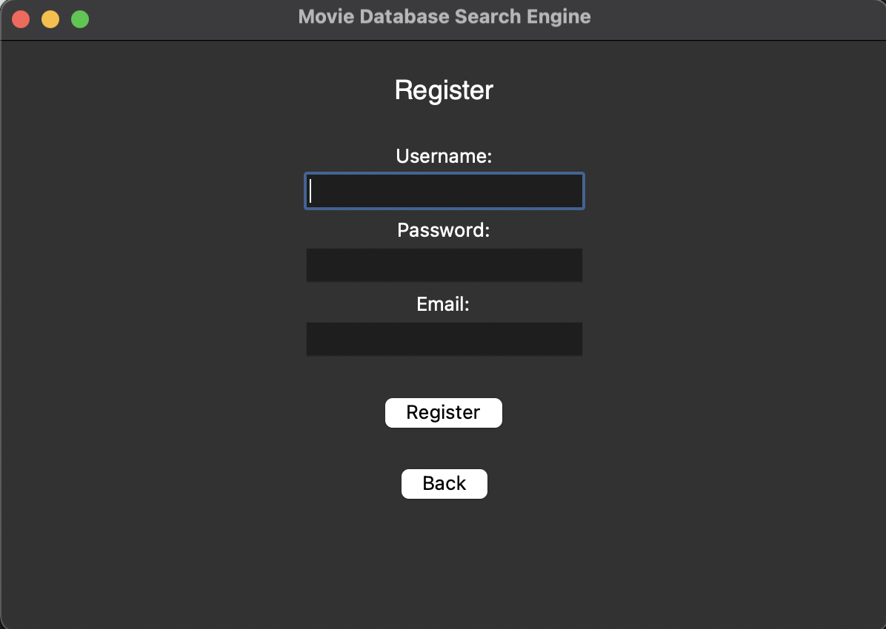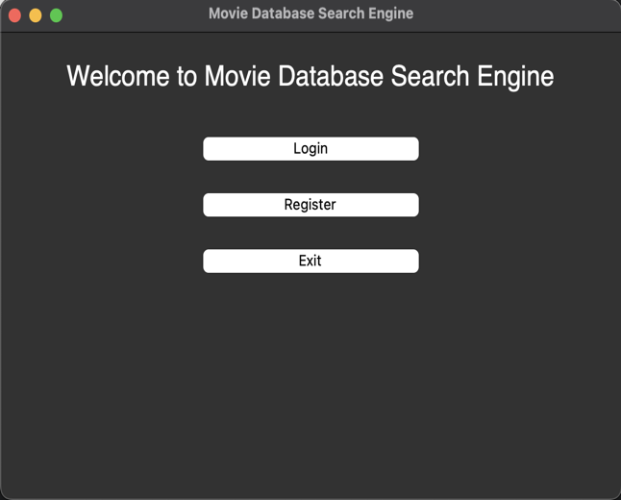Screenshots:

* Schemas:

* Changes and updates:
  + Initially, we were to develop a Database Website. But near the end of the course, Thy Tran decided to work on her own, leaving me and Hang have to change our path to using all Python for the app.
* SQL related:
  + Please kindly check out our Github repository, where we store the following:
    - Table initialization, data (cleaned and separated) import named …
    - Raw data
    - Queries that connect Python and Database together